بسم الله الرحمن الرحيم
منظمـــــة براكتكـــــال آكشــــن – الســــــــودان
التاريخ: 31 يناير 2022
رقم العطاء: FASH-KRT-SDN36093-01-22-PR005
توريد عدد 1000 محراث للمزارعين لمشروع وادى الكوع بمحلية الفاشر – ولاية شمال دارفور
براكتكال آكشن منظمة دولية متفردة بإستخدامها أفكارا خلاقة ومبتكرة لتحويل واقع الإنسان في الدول النامية إلى الأفضل، نعمل فى مكاتب إقليمية فى المملكة المتحدة، أفريقيا، آسيا، و أمريكا الاتينية.
بدأت منظمة براكتكال آكشن العمل فى السودان و تم تسجيلها بصفة مستقلة كمنظمة دولية غير حكومية في العام ١٩٩٢، للمنظمة مكاتب وبرامج في ولايات شمال دارفور، كسلا و النيل الازرق.
ترغب منظمة براكتكال اكشن من الموردين والمقاولين الشركات الاكفاء بتقديم عروضهم لتوريد عدد 1000 محراث للمزارعين لمشروع وادى الكوع بمحلية الفاشر – ولاية شمال دارفور. وفقا للشروط و المواصفات الواردة بكراسة العطاء.
على المتقدمين للعطاء ارفاق المستندات الموضحة ادناه:
1/ الســيرة الذاتية للشركة
2/ شهادة مقدرة مالية بتاريخ السنة المالية للعطاء.
3/ صورة من شهادة خلو طرف من الضرائب بتاريخ السنة المالية, ومن يرسو عليه العطاء ملزم باحضار الاصل.
4/ شهادة تسجيل من المسجل التجاري .
5/ شهادة تسجيل ضريبة على القيمة المضافة.
6/ كشف حساب بنكى لاخر ستة اشهر حتى تاريخ العطاء.
7/ ملء وارفاق كراسة العطاء مشتملة على كل التفاصيل المطلوبة.
8/ خطاب مروس من الجهة المتقدمة للعطاء معنون لمنظمة براكتيكال اكشن يحتوى على (تاكيد نوع وكميات الخدمة المطلوبة / المبلغ الكلى للعطاء شامل القيمة المضافة/الزمن المقرر لاكتمال تقديم الخدمة فى الموقع/ اسم وعنوان وتلفون وتوقيع الشخص المفوض من قبل الجهة المتقدمة للعطاء).
9/ تقدم المستندات اعلاه فى ظرف مغلق بالشمع الاحمر ومكتوب عليه (مرفق استيكر- هذه البيانات و يجب ان يلصق على ظرف العطاء). رقم العطاء/اسم العطاء / اسم مقدم العطاء و عنوانه و ارقام الهواتف.
10/ كل ظرف يجب ان يحتوى على عطاء واحد فقط بمعنى عدم التقديم لاكثر من عطاء فى ظرف واحد.
11/ اى متقدم غير مستوفى للمتطلبات اعلاه يستبعد من المنافسة
12/. للحصول على كراسة العطاء (مجاناً) يرجى الاتصال بالمنظمة اثناء ساعات العمل من الساعة 8:30 صباحاً حتى الساعة 2:30 مساء بمقر المنظمــــة بالخرطوم المعمورة مربع 72 مبنى رقم 12 (شـــارع مدني مع تقاطع الستين شمال مكتب ضرائب المعمورة) وجنوب غرب برج شركة زين للإتصالات تلفونات: 0155661960 0912140393 - - 0914330199 او بمكتب المنظمة بالفاشر تلفون :- 155662472-1556619590912513017
اخر موعد لتسليم العطاءات 21 فبراير 2022 الســـــاعة الثانية نهارا بمـــقر المنظمة بالخرطوم او مكتب الممنظمة بالفاشر .
المنظمة غير مقيدة بقبول أعلى أواقل عطاء, والمستندات المقدمة للعطاء لاترد

أولأ/ شروط العطاء:
- احضار ملف الشركة لمعاينته بواسطة لجنة تأهيل الموردين لاضافته لكشف الموردين الخاص بالمنظمة.
- يجب توفير الضمانات اللازمة لتنفيذ و توريد كل الاعمال المتفق عليها فى العقد بالمعايير و الجودة المتفق عليها.
- . علي المتقدم ان يوضح في عطاءه الأسعار بالجنيه السودانى وان تكون الاسعار شاملة لضريبة القيمة المضافة ، وفي حال رسو العطاء لأى من المتقدمين يجب عليه تقديم فاتورة نهائية مختومة بختم الضرائب
- الأسعار يجب ان توضح على جداول الكميات و المواصفات وان تكون مختومة بختم الجهة المتقدمة للعطاء.
- يجب ان تكون الاسعار الموضحة بجدول الكميات و المواصفات سارية المفعول لمدة اسبوعين من تاريخ تقديم العرض.
- ستتم مراجعة الاسعار بصورة دورية للتاكد من مواكبة الاسعار المقدمة للسوق.
- يجب على المتقدم الرجوع الى شروط المناقصة والمواصفات قبل التقديم.
- اي كشط او تعديل في الاسعار الموضحة فى جداول الكميات و المواصفات غير موقع ومختوم بواسطة المتقدم بالعطاء يحرمه من دخول المناقصة .
- لجنة فرز المناقصات لها الحق كاملاً في الغاء المناقصة متى ما رأت ذلك ضروريا او لاي اسباب اخرى فنيه تراها اللجنة.
- على الراغبين تقديم العطاءات في ظروف مقفولة و مختومة بالشمع الاحمر توضع في صندوق المناقصات بمكاتب المنظمة بالعناوين الموضحة ادناه:
- للحصول على كراسة العطاء (مجاناً) يرجى الاتصال بالمنظمة اثناء ساعات العمل من الساعة 8:30 صباحاً حتى الساعة 2:30 مساء بمقر المنظمــــة بالخرطوم المعمورة مربع 72 مبنى رقم 12 (شـــارع مدني مع تقاطع الستين شمال مكتب ضرائب المعمورة) وجنوب غرب برج شركة زين للإتصالات تلفونات: 0155661960 0912140393 - - 0914330199 او بمكتب المنظمة بالفاشر تلفون :- 155662472-1556619590912513017

- اخر موعد لتسليم العطاءات 21 فبراير 2022 الســـــاعة الثانية نهارا بمـــقر المنظمة بالخرطوم او مكتب الممنظمة بالفاشر . ولن تقبل اي عطاءات بعد التاريخ و الزمن المحددين.
- الرجاء ملْ اخطار المناقصة المدمج فى كراسة العطاء لتوحيد مواصفات العطاء لكل الموردين المتقدمين للمنافسة والتوقيع والختم عليه مع توضيح طريقة الدفع (كاش / شيك / تحويل ) ورقم الحساب البنكى , اى عطاء لايحتوى على كراسة العطاء مكتملة سوف يبعد من المنافسة.
- في حالة عدم تقديم الموردين المعتمدين بكشف المنظمة يرجى الاعتذار كتابة مع رد مستندات العطاء ، وفي حالة الاخلال بهذا الشرط سوف يتم استبعاد المورد من كشف الموردين الخاص بالمنظمة.
- للمنظمة الحق في أضافة كميات جديدة أوتقليل عدد المرافق الموصوفة في جدول الكميات وبنفس أسعار العقد في زمن تنفيذ العقد.
- علي المتقدم فى حالة مخالفة المواصفات المطلوبة و المنصوص عليها في كراسة العطاء ذكر ذلك كتابة و تفصيلا لتوضيح اسباب التقديم بعرض مخالف للمواصفات.
- للمنظمة الحق في التعاقد مع مورد واحد أو أي عدد من الموردين حسب ما تراه مناسبا لها .
- للمنظمة الحق في مراجعة الوحدات الموردة و التأكد من جودة تنفيدها ومطابقتها للمواصفات المطلوبة
- للمنظمة الحق في رفض استلام اي وحدة من الوحدات المتفق عليها فى العقد غير مطابق للمواصفات المطلوبة حسب شهادة المختصين ممن تكلفهم المنظمة بالإستلام علي أن يتحمل المورد اى خسارة تنتج عن ذلك وتخصم من حسابه طرف المنظمة.
- يتم الدفع حسب شروط العقد المتفق عليها وتحرر شهادة استلام بذلك طبقا للمواصفات المرفقة مع المناقصة والتقييم الفنى.
- من يرسو عليه العطاء ملزم بملْ معلومات رقم حسابه البنكى كتابة لتحويل قيمة العطاء بصورة صحيحة و المنظمة غير مسؤلة عن اى خطأ ينتج من المورد فيما يختص برقم حسابه.
- من يرسو عليه العطاء ملزم بتوقيع اشعار استلام سياسات المنظمة (مرفق) فيما يتعلق بملئ استمارة تقييم (الشركاء والموردين ومقدمى الخدمات) وارجاعها للمنظمة لاكمال ملف المورد قبل اجراءات الدفع, وسيايات المنظمة الاخرى المتعلقة بالالتزام بالنذاهة ومناهضة و مكافحة الرشوة والغش والاختلاس وذلك لضمان و تاكيد التزام المنظمة وكل الشركاء والاطراف التى تتعامل معها المنظمة من موردين ومقدمى خدمات ملتزمون بتطبيق هذه السياسات وان اى خصم فى قيمة السلع او الخدمات من قبل المورد يجب ان يوضح كتابة لعدم اهدارموارد المنظمة و تقليل التكاليف لاقصى حد لفائدة برامج ومشاريع عمل المنظمة.
- المنظمة غير ملزمة بقبول أدني أو إي عطاء آخر ولها حق رفض أي عطاء حسب لوائح المنظمة .
- على من يرسو عليه العطاء احضار اى كاتلوجات ان وجدت لمعاينتها من قبل الجهة الفنية لاعتمادها قبل الشروع فى عملية التوريد و التنفيذ.
- من يرسو عليه العطاء يلتزم بترحيل كل المواد و الاصناف المتفق عليها فى العقد الى مواقع تنفيذ العقد فى ولاية شمال دارفور دون اى تأخير, التأخير غير المبرر يؤدى الى الغاء العقد الموقع بين المنظمة و المورد دون اى قيد او شرط.
- تتم عملية التسليم و التسلم النهائية بعد بعد التاكد من توافق المواد الموردة والخدمة مع المواصفات المطلوبة بحسب الراى الفنى للمختص من طرف المنظمة.
- لضمان تنفيذ سياسة عدم تضارب المصالح -على المتقدمين للعطاء توضيح ما اذا كانت لكم اى صلة قرابة باى من الموظفين التابعين لمنظمة براكتيكال اكشن حاليا او سابقا ( ان وجد الرجاء زكر الاسم وصلة القرابة).
- من يرسو عليه العطاء يلتزم بتدريب الفنيين العاملين بالمشروع و المستفيدين على التشغيل و الصيانة اثناء عملية التنفيذ.
- المستندات المقدمة من قبل الموردين لا ترد .

ثانيا: المرجعية وجداول الكميات:

Practical Action – Sudan

Practical Action Sudan

Terms of Reference (TOR)-PR005-JAN22

For

Purchase and provision of 1000 ploughs for farmers on revolving fund basis
1. Background:
Practical Action is an international NGO that has been working in Darfur since 1988. Practical action now is implementing Wadi El Ku Catchment Management Project-Phase II (WEK-II) seeks to achieve sustainable improvements in agricultural and related livelihoods through the improved management of natural resources. The project will continue to strengthen livelihoods and achieve sustainable increases in agricultural and related value-chain production in a wider area of the wadi from Umsayala upstream to Wada’a downstream (about 180 km) through the rehabilitation and improved management of its land, forest and water resources. Therefore, Practical Action will carry out some activities during the implementation of this PCA under the UN Environment Wadi El Ku Catchment Management Project – Phase 2. During this period, Practical Action will work closely with the UN Environment project team and in partnership with relevant government institution and the targeted communities .
The project will achieve this outcome by applying UNEPs knowledge and experience with environmental governance and integrated water resource management to the natural resource management challenges of Wadi El Ku. Concretely, the project will continue to enhance agricultural production system applying techniques and tools aligns with applied catchment management system in the project area, which will allow small farmers to grow and produce their main crops in sustainable manner, this will open up and improve livelihood options and increased their income and diversify the income sources. In last year farmer’s such activities regards improvement of agro- practices by different extension approaches, drought tolerant seeds and vegetables crops on community management cost recovery system were provided. Training on soil conservation and better management
The project activities will continue to demonstrate and promote improved agricultural and natural resource management approaches, extension packages, and cooperation mechanisms (convening pastoralists and farmers over water and natural resources) for uptake at community level Accordingly, Practical Action will work with UN Environment, ministry of agriculture and animal resources and blacksmith association to provide 1000 ploughs for farmers on revolving fund basis. Blacksmith association is a group of blacksmiths who originally has experience in making agricultural tools, they have been well trained technically and managerially and well organized by Practical Action, and they have long experience in ploughs manufacturing.

2- Justification:
Animal plough is a farm tool for loosening or turning the soil before sowing seed or planting. Ploughs were traditionally drawn by Donkeys and horses, but in modern farms are drawn by tractors.
Animal plough is most important for agricultural implement since the beginning of history, used to turn and break up soil, to bury crop residues, and to help control weeds. Animal plough generally used for tilling of soil helps in loosening and turning off the soil, the nutrient-rich soil is distributed evenly and also it improves aeration. - Ploughing helps to improve the water retention ability of soil in the form of capillary water. - It is essential for the uprooting of weeds and unwanted herbs. Therefore, farmers will support them with donkey plough on basis of revolving basis according to specific criteria for selection, the selection criteria will be developed later during consultation session with the targeted community, the project prefer the distribute and reimbursement process will be managed by community CBOs.

3- Ploughs Specifications:
- the plough should have steel frame with a blade allowed to cut and loosen the soil
- the performance of the plough should be inversion of the soil and trash covering especially when the soil was relatively moist
- the plough should be suitable for of donkey traction

4- Location for provision:
The improved ploughs should be delivered to Practical Action Office - North Darfur in Elfasher town.

5. Timeframe of the work:
The proposed duration of this activity is approximately 2 months .

# | Description | Unit | Quantity | Unit Price | Total Price
1. | Ploughs for Farmers as per as per above  Specifications and below designs. | PCs | 1000
VAT%
TOTAL

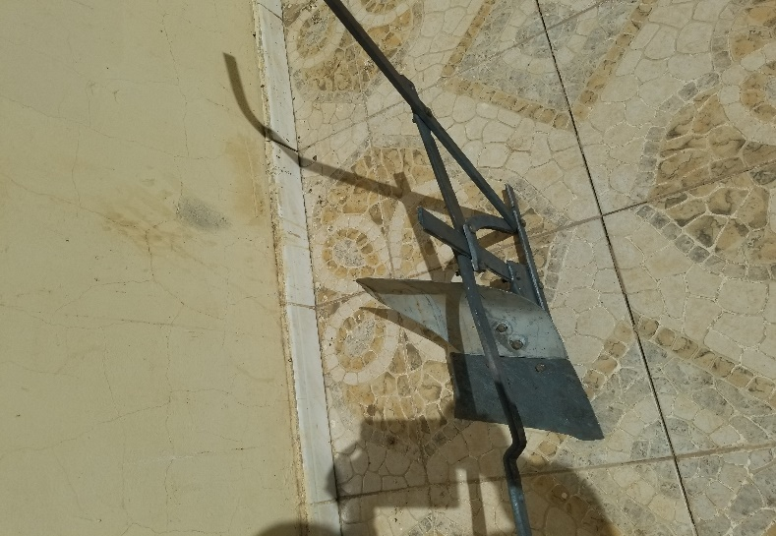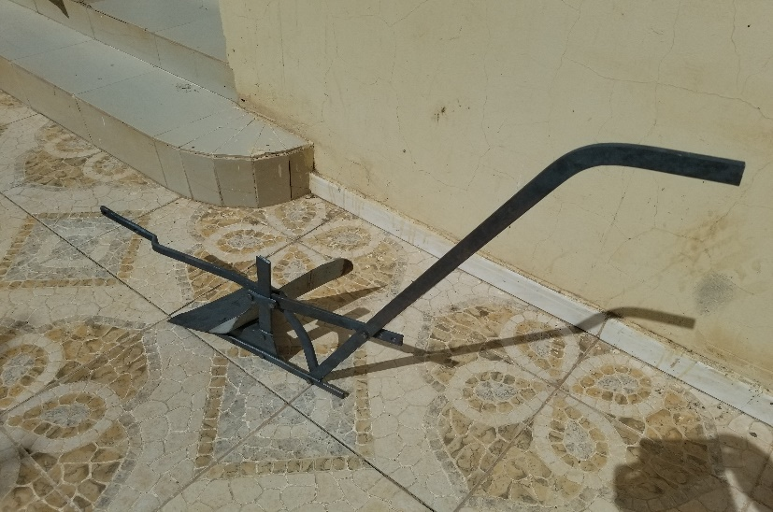

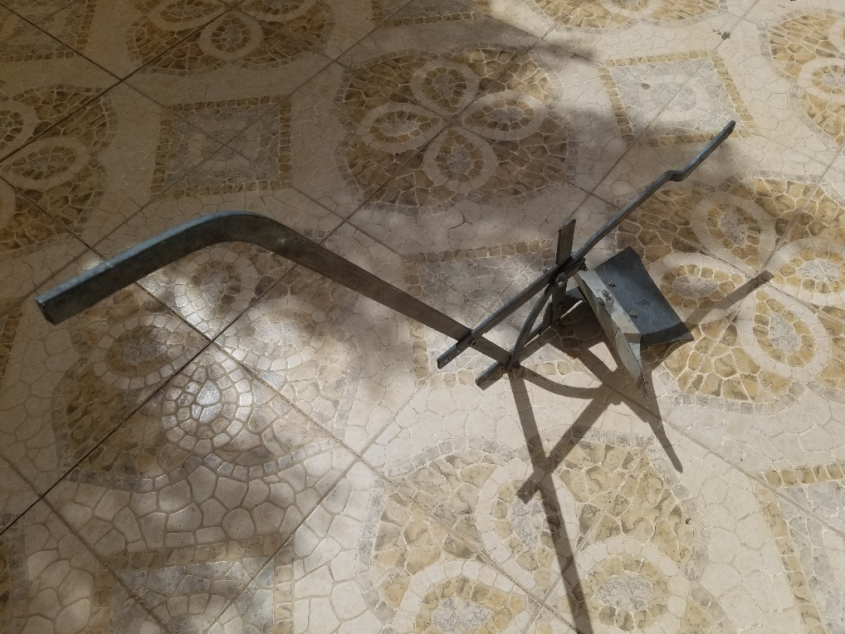

- please attach designs and pictures for the product you provide in case it’s different than the above design

ثالثاً: التكاليف وزمن تسليم الخدمة بالموقع وتفاصيل المورد:
المبلغ الكلي بالارقام بالجنيه السودانى :...................................................................................................
المبلغ الكلى بالجنيه بالحروف....................................................................................................................
الزمن المقدر لأنجاز واكمال وتسليم الخدمة بالموقع: ......................................................................................
اسم الشركة / المورد:..........................................................................................................................
العنوان:..........................................................................................................................................
اسم من ينوب عن الشركة:....................................................................................................................
الوظيفة:.........................................................................................................................................
التوقيع:..........................................................................................................................................
الختم:............................................................................................................................................
البريد الالكترونى:..............................................................................................................................
الهاتف:..........................................................................................................................................

رابعا سياسات المنظمة الملزمة للطرفين:
Annex: 1

Practical Action Terms and Conditions for Supply, Service and Works Contracts
- LEGAL STATUS
The Vendor shall be considered as having the legal status of an independent contractor vis-à-vis PA.
The Vendor, its personnel and sub-contractors shall not be considered in any respect as being the employees of PA.
The Vendor shall be fully responsible for all work and services performed by its employees, and for all acts and omissions of such employees.
- SUB-CONTRACTING
In the event the Vendor requires the services of a sub-contractor, the Vendor shall obtain the prior written approval of PA for all sub-contractors. The Vendor shall be fully responsible for all work and services performed by its sub-contractors and vendors, and for all acts and omissions of such sub-contractors and vendors. The approval of PA of a sub-contractor shall not relieve the Vendor of any of its obligations under this Contract. The terms of any sub-contract shall be subject to and conform to the provisions of this Contract.
- OBLIGATIONS
The Vendor shall neither seek nor accept instructions from any authority external to PA. Vendors may not communicate at any time to any other person, government or authority external to PA any information known to them by reason of their association with PA which has not been made public, except in the course of their duties or by authorization of the PA: nor shall Vendors at any time use such information to private advantage. These obligations do not lapse upon termination/expiration of their agreement with PA.
- ACCEPTANCE AND ACKNOWLEDGEMENT
Initiation of performance under this contract by the vendor shall constitute acceptance of the contract, including all terms and conditions herein contained or otherwise incorporated by reference.
- WARRANTY
The Vendor warrants the goods furnished under this Contract to conform to the specifications and to be free from damage and defects in workmanship or materials. This warranty is without prejudice to
Any further guarantees that the Vendor provides to purchasers. Such guarantees shall apply to the goods subject to this Contract.
- INSPECTION
The duly accredited representatives of PA shall have the right to inspect the goods called for under this Contract at Vendor’s stores, during manufacture, in the ports or places of shipment, and the Vendor shall provide all facilitates for such inspection. PA may issue a written waiver of inspection at its discretion. Any inspection carried out by representatives of PA or any waiver thereof shall not prejudice the implementation of the other relevant provisions of this Contract concerning obligations subscribed by the Vendor, such as warranty or specifications.
- EXPORT LICENCE
The Contract is subject to the obtaining of any governmental authorization that may be required. It shall be the responsibility of the Vendor to obtain such license or authorization. PA may, at its discretion, use its best endeavors to assist.

- OFFICIALS NOT TO BENEFIT
The Vendor represents and warrants that no official of PA has been, or shall be, offered by the Vendor any direct or indirect benefit arising from this Contract or the award thereof. The Vendor agrees that breach of this provision is breach of an essential term of this Contract.
- DEFAULT
In case of default by the Vendor, including, but not limited to, failure or refusal to make deliveries within the limit specified, PA may procure the goods or services from other sources, and hold the Vendor responsible for any excess cost occasioned thereby. Furthermore, PA may, by written notice, terminate the right of the Vendor to proceed with deliveries or such part or parts thereof as to which there has been default.
- REJECTION
In the case of goods or services purchased based on specifications or scope of works, PA shall have the right to reject the goods or services or any part thereof if they do not conform to specifications or the scope of works.
- AMENDMENTS
No change in or modification of this Contract shall be made except by prior agreement between the Responsible Buyer in PA in Sudan and the Vendor.
- ASSIGNMENTS
The Vendor shall not assign, transfer, pledge or make other disposition of this Contract or any part thereof or of any of the Vendor’s rights, claims or obligations under this Contract except with the prior written consent of PA.
ADDENDUM TO PARTNER AGREEMENT
- PURPOSE
  - This is an Addendum to Agreement No. ____________ concluded between Practical Action and [NAME OF ORGANISATION], the Partner, which came into force on [date of start of agreement].
  - This Addendum forms an integral part of the Agreement, including all its other terms and conditions
  - By signing this Addendum, the Partner agrees to ensure that all its staff, consultants, partners, volunteers and trustee comply with all the terms and conditions included herein and which form part of the original Agreement between Practical Action and the donor and are an integral part of Practical Action’s policies and code of conduct.
- PROTECTION OF CHILDREN AND VULNERABLE ADULTS
Practical Action firmly believes that no person, including children and vulnerable adults, should be subjected to exploitation or abuse at any time. We are committed to ensuring that all our staff, partners, consultants, volunteers and trustees fully abide by our Policy on the Protection of Children and Vulnerable Adults at all times. Within the Partner, this policy applies to all staff, volunteers, consultants, or sub-partners who are involved with this project in any way.
The Partner commits to:
  - Fully integrate the Policy within your organisation ensuring that the policy is adopted and procedures and capabilities are developed to prevent the abuse or exploitation of children and vulnerable adults in your work, implement a clear and effective reporting system for any concerns
or incidents of exploitation or abuse and define robust management processes for handling any concerns or incidents, OR
  - Confirm to Practical Action that you have your own robust policy on the Protection of Children and Vulnerable Adults, AND
  - Ensure that any concerns or incidents of exploitation and abuse of children and vulnerable adults related to the project funded by this Agreement are reported to Practical Action within 24 hours of your organisation becoming aware of them and that Practical Action, as the primary recipient of the award, is regularly informed of all actions taken in the response.
The Partner agrees that it will work with Practical Action to take disciplinary actions and to inform authorities, where appropriate. Depending on the outcomes of investigation, the Partner acknowledges that Practical Action will inform the donor and its regulatory body.
- COMPLIANCE WITH THE LAW AND REPORTING OBLIGATIONS
Practical Action is committed to complying with all relevant laws in the UK and in all the countries where it works as well as with meeting its reporting obligations to relevant national and international bodies, including the Charity Commission for England and Wales.
By signing this Addendum, the Partner also commits to compliance with all laws in the country/ies where the work related to this Agreement is being implemented and to meeting its reporting obligations to relevant national and international bodies, including providing Practical Action with all accurate and timely information that enables Practical Action to meet all its reporting obligations.
- CONFLICT OF INTEREST
Neither the Partner, nor any individual employed or contracted by the Partner, shall engage in any business, personal or professional activity which conflicts or could conflict with any of their obligations in relation to this Agreement.
- FRAUD, CORRUPTION, BRIBERY, THEFT, TERRORIST FINANCING AND OTHER MISUSE OF FUNDS
  - Practical Action and the Partner have a zero tolerance approach towards fraud and fraudulent behaviour that may lead to the misuse of funds and will fully co-operate with investigation into
Such events, whether led by Practical Action or the Partner. Practical Action, may, at any time during the term of this arrangement and up to five years after the end of the programme, arrange for additional audits, on-the spot checks and / or inspections to be carried out. These may be carried out by Practical Action, or any of its duly authorised representatives.
  - The Partner will comply with Practical Action’s Fraud Detection Policy OR confirm that they will comply with their own Fraud Detection Policy, of similar standard. The Partner commits to investigate suspected fraud and to do so with the utmost confidentiality.
  - The Partner will immediately and without undue delay inform Practical Action of any event which interferes or threatens to materially interfere with the successful implementation of the project, whether financed in full or in part by this Agreement, including credible suspicion of or actual fraud, bribery, corruption or any other financial irregularity or impropriety.
  - Practical Action reserves the ability to recover funds that have been subject to a proven fraud and will work with the Partner to do so. The Partner shall not be obliged to cover such funds unless such fraud is proven to be caused by gross negligence or wilful misconduct of the Partner or its staff members. Where serious fraudulent or unethical activity is proven which would significantly affect the successful completion of the Project, Practical Action reserve the ability to suspend or terminate funding with immediate effect in whole or partial, in preference to the standard notice period and irrespective of any contractual requirements.
  - Consistent with local and international legislations and applicable United Nations Security Council resolutions both Practical Action and the Partner are firmly committed to the international fight against terrorism, and in particular, against the financing of terrorism. It is the policy of Practical Action to seek to ensure that none of its funds, including funds that are provided by donors, are used, directly or indirectly, to provide support to individuals or entities associated with terrorism. In accordance with this policy, Practical Action and the Partner make themselves aware of, and comply with obligations under the relevant counter terrorist financing legislations.

ACKNOWLEDGMENT
This to confirmed that I received the Practical Action Safe Guarding Policy Arabic version and by Signing this acknowledgment I confirmed that I read it, understand it, and aware of any consequences resulting in breaching the mentioned Policy.
I also received the Terms and conditions of Practical action read it and understand it, I also receive the DD Assessment tool and will fill and return it back to PA being donor HQ requirements.
ارجو ان افيدكم باستلامى لسياسة المنظمة النسخة العربية وبالتوقيع ادناه اقر باننى قد قرات محتواها وفهمت ما يترتب على مخالفة هذه السياسة من اجراءات. كما افيدكم باستلامى لشروط المنظمة وقرات محتواها وفهمت ما فيه. كما اقر باستلامى لاستمارة تقييم الشركاء والموردين ومقدمى الخدمات وساقوم بملء الاستمارة وارجاعها للمنظمة باعتبارها مطلوبات مانحين.

Name:……………………………………………..…........................…………………………………الاسم
Signature:………......…………………..…………......................……………….……………….التوقيع
Company:…………………………………………......................…...................……………..الشركة
Stamp: الختم.........................................................................................................
Date:…………………………………………….....................……......................……………..التاريخ

Practical Action Partner
Due Diligence Questionnaire
Practical Action is committed to upholding the highest possible standards and ethics when delivering our work. This includes protecting staff members and the people living in the communities where we work from exploitation and abuse, protecting ourselves and our donors from financial crime, and ensuring compliance with all donor regulations and local / national laws. We expect the organizations and individuals we work with to uphold the same values and commitments.
In order to work with Practical Action, an organization must demonstrate that it has the technical capacity, experience, and ability to perform the assigned work, as well as having sufficient processes and procedures in place to ensure it can deliver the work according to the regulations imposed by both Practical Action and the Source Donor.
As part of Practical Action’s due diligence assessment, we need to ensure that your organization:
- is properly registered with the relevant authorities in your country of operation, and is compliant with national tax requirements;
- has suitable control mechanisms and operational protocols in place to deliver the project activities in line with donor regulations;
- is able to meet Duty of Care obligations to staff, consultants, and people living in the areas where we will work;
- is financially robust and has the necessary policies in place to prevent fraud, financial crime, and terrorist financing
The due diligence assessment is a self-declaration made by you, the potential partner, to provide information regarding your current organizational policies, procedures, registrations, and resources.
It is important that the pre award assessment is completed accurately and truthfully - your organization will not be automatically disqualified from working with Practical Action if you do not have everything in place. Instead, it allows us to identify areas where we may have to share resources in order to comply with the requirements of major institutional donors - while also providing Practical Action with the assurance that your organization is compliant with all applicable laws, rules, and regulations, and acts in accordance with the highest standards of ethics.
In the event that Practical Action issues a subaward to your organization, this declaration should be completed and resubmitted annually ahead of further payments.
When completed, this assessment should be returned to the Practical Action contact point with the relevant supporting documentation. Please note, failure to complete the assessment will prevent the formation of any bidding agreement and/or may delay the payment of a subaward.
FOR DFID CONTRACTS ONLY (delete if not applicable) To ascertain the level of compliancy required by your organisation please provide us with the following information
Current number of contracts with the UK Government and the total value (in GBP) | Number
 | Value (GBP)

Part 1: Organisation Details
1A: Contact Details for all queries relating to this assessment questionnaire
Name:
Email:
Phone:

1B: Registration
Registered Company Name

Registered Company Number
Country of Registration
Date of Registration
Head Office DUNS number (if applicable)
Registered VAT number (if applicable)
Registered Office Address
Please indicate your type of organisation
Ultimate / Parent Company (if applicable)
Name of subsidiary companies (if applicable)

1C: Governance and Control
Please provide the following information for your organisation.
Name of Managing Director / Chief Executive Officer
Names of Company Board Member(s)
Names of Senior Leadership / Management team
Name of shareholders and percentage of shareholding (if applicable)
Names of Affiliated Organisation(s) (if any)
Does your organisation have an accounting system in place that will enable Practical Action to readily identify the assets, expenses, cost of goods, and use of funds for any subaward we may provide. | Yes ☐ No ☐
Does your organisation have a Quality Assurance (Contract Management) manual, policies, certification and/or systems in place? | Yes ☐ No ☐
Does your organisation maintain a formal risk register and monitor mitigation plans? | Yes ☐ No ☐

1D: Insurance
Please confirm whether you have the following insurance cover in place | Professional Indemnity: | Yes ☐ No ☐
 | Public Liability: | Yes ☐ No ☐
 | Employer’s Liability: | Yes ☐ No ☐
 | Travel Insurance: | Yes ☐ No ☐

1E: Duty of Care
As the lead partner, Practical Action are responsible for ensuring our partners and subcontractors have adequate duty of care provisions in place. Please confirm the following stating ‘Yes’ or ‘No’ with any relevant explanations.
Does your organisation have travel policy, risk assessment, and emergency procedure in place | Yes ☐ No ☐
Has your organisation got appropriate systems in place to manage an emergency / incident if one arises? | Yes ☐ No ☐
Please provide details below

1F: International Aid Transparency Initiative (IATI) - delete section for Partners under level 1
DFID require organisations receiving funding to comply with the International Aid Transparency Initiative (IATI) standards of transparency for their disbursement of UK aid.
Is your organisation registered on IATI? | Yes ☐ No ☐
If Yes, please provide reference number

1G: Ethical Training
Do your staff undergo ethical training and annual staff updates (including awareness of modern day slavery and human rights abuses). | Yes ☐ No ☐
If No, please confirm that you will be willing to follow and implement Practical Actions ethical training procedures | Yes ☐ No ☐

1H: Cyber Essentials Scheme - delete section for Partners based outside the UK and/or under level 2
Do you have a system to safeguard the integrity and security of your IT and mobile communication systems in line with the HMG Cyber Essential Scheme | Yes ☐ No ☐

Part 2: Disclosures
Please complete the below disclosure form with a ‘Yes’ or ‘No’ in the right hand column
Your organisation must disclose:
a) If the organisation or any affiliated companies
…are or have been the subject of any proceedings or other arrangements relating to bankruptcy, insolvency or financial standing. | Yes ☐ No ☐
…have been convicted of any offence concerning professional misconduct. | Yes ☐ No ☐
…has not fulfilled any obligations relating to the payment of social security contributions. | Yes ☐ No ☐
…have had any media coverage (including online or print) that could impact the reputation of Practical Action or its clients | Yes ☐ No ☐
If you have replied Yes to any of the above please provide details below:
b) If your organisation, affiliated companies or an employee (past and present within the last 10 years) has been convicted of, or are the subject of any proceedings, relating to…
…participation in criminal organisation. | Yes ☐ No ☐
...corruption including the offence of bribery | Yes ☐ No ☐
…fraud including theft, and not fulfilling any obligations relating to payment of taxes. | Yes ☐ No ☐
…terrorist offences or offences linked to terrorist activities | Yes ☐ No ☐
…money laundering and terrorist financing | Yes ☐ No ☐
…child labour and other forms of trafficking in human beings | Yes ☐ No ☐
…breach of environmental obligations | Yes ☐ No ☐
…breach of social obligations | Yes ☐ No ☐
…breach of labour law obligations | Yes ☐ No ☐
… are subject of any proceedings, that may be listed by the World Bank in its ‘Listings of Ineligible Firms” or “Listings of Firms, Letters of Reprimand’ posted at or on any similar list maintained by any other donor of development funding, or any contracting authority. | Yes ☐ No ☐
If you have replied Yes to any of the above please provide details below:
b) Modern Slavery Act 2015: Requirements under Modern Slavery Act 2015 and UN Global Compact Requirements for active participation.
Are you a relevant commercial organisation as defined by Section 54 ("Transparency in supply chains etc.") of the Modern Slavery Act 2015 ("the Act")? | Yes ☐ No ☐
If yes, are you compliant with the annual reporting requirements contained within Section 54 of the Act 2015?  Please provide link to URL: | Yes ☐ No ☐
Is your organisation an active participant of the UN Global Compact?  If yes, please provide link to URL: | Yes ☐ No ☐

Part 3: Please indicate ‘Yes’ or ‘No’ as to whether your organisation has documented policies and procedures for the following matters.
Recruitment policy, procedures and/or organisational HR manual incorporating the following:  - Fair recruitment practices  - Due diligence and reference assessment  - Equal opportunities | Yes ☐ No ☐
Quality Assurance policy, procedures and/or certification | Yes ☐ No ☐
Duty of Care policy and procedures | Yes ☐ No ☐
Finance manual / Protection from Financial Crime policy or equivalent | Yes ☐ No ☐
Gifts and hospitality | Yes ☐ No ☐
Procurement policy | Yes ☐ No ☐
Workforce whistleblowing policy | Yes ☐ No ☐
Safeguarding policy | Yes ☐ No ☐
Anti-bribery/corruption policy | Yes ☐ No ☐
Anti-trafficking/modern day slavery policy | Yes ☐ No ☐
Data protection policy | Yes ☐ No ☐
Duty of Care/Security policy | Yes ☐ No ☐
Environmental policy | Yes ☐ No ☐
Identification and management of conflicts of interest | Yes ☐ No ☐
Health and Safety | Yes ☐ No ☐
Information technology/ data security | Yes ☐ No ☐
Risk management | Yes ☐ No ☐
Code of conduct | Yes ☐ No ☐
If you have answered ‘no’ to any of the above, please provide confirmation that you will comply with Practical Actions applicable policies and procedures. | Yes ☐ No ☐

Part 4: Declarations
This section is to be completed by the CEO or relevant senior member of your management team.
By signing below I confirm that I (insert name) as the (job title ) of (insert organisation name)
- consents to Practical Action running the names of the organisations and individuals listed in section 1C above against international databases as part of our anti-terrorist financing checks
- Confirm that we have adequate processes and systems in place to examine the suitability of sub-contractors to operate on our behalf, and we ensure sufficient oversight of them and their activities to fulfil our contractual obligations.

- Confirm that we are able to provide evidence of due diligence undertaken on our subcontractors if requested, and that we understand Practical Action may conduct spot checks.
FOR DFID FUNDED CONTRACTS ONLY (please delete as appropriate)
- I declare that I have read, understood and accept the DFID supply partner Code of Conduct and that appropriate procedures have been put in place to ensure adherence to the Code by all employees, partners and subcontractors within our supply chain.
(https://www.gov.uk/government/publications/dfids-supplier-review)

- confirm that my staff and subcontractors have been made aware that any instances of conflict of interest, fraud, unethical behavior or misconduct should be reported to the DFID reporting concerns mailbox reportingconcerns@dfid.gov.uk

I hereby certify that all information contained within this document is true, correct and not misleading in anyway. I understand that the information will be used in the process to assess my organisations suitability to be selected as a partner and I am signing on behalf of my organisation.
Signature: Date:
Name Job Title
Please provide a copy of the following documents when returning your assessment questionnaire to us
- Company registration certificate
- Proof of tax registration
- Copy of Audited Accounts for the past 3 years
- Copy of all insurance certificates as listed in section 1D
- Copy of project risk register template
- Cyber essentials certificate (if applicable)
- 2 Past performance certificates / statements of recommendations from previous donors / clients within the past three years
- Copy of the policies/documents listed in Part 3 of this form

